实验1 测量载流圆线圈轴线上磁场的分布

|  |  |  |  |  |  |  |  |  |  |  |  |
| --- | --- | --- | --- | --- | --- | --- | --- | --- | --- | --- | --- |
| 轴向距离 | 5.00 | 4.00 | 3.00 | 2.00 | 1.00 | 0.00 | -1.00 | -2.00 | -3.00 | -4.00 | -5.00 |
| 磁感应强度 | 703 | 786 | 862 | 925 | 972 | 981 | 957 | 914 | 845 | 773 | 691 |

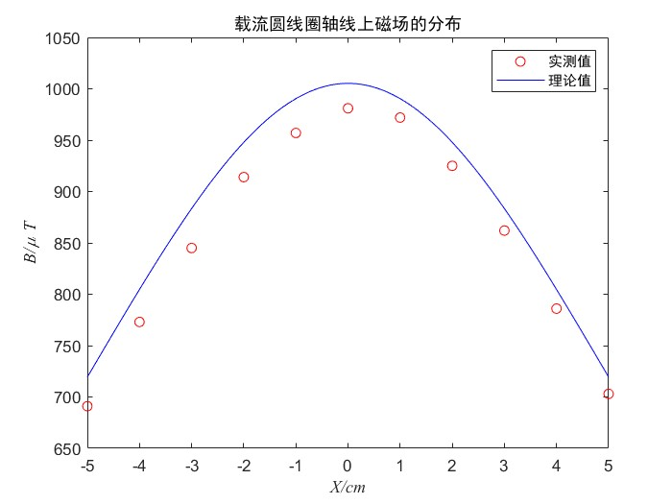理论值计算公式

时，理论值

相对误差

时，理论值

相对误差

时，理论值

相对误差

时，理论值

相对误差

时，理论值

相对误差

实验2 测量载流圆线圈中心平面径向磁场的分布

|  |  |  |  |  |  |  |  |  |  |  |  |
| --- | --- | --- | --- | --- | --- | --- | --- | --- | --- | --- | --- |
| 轴向距离 | 5.00 | 4.00 | 3.00 | 2.00 | 1.00 | 0.00 | -1.00 | -2.00 | -3.00 | -4.00 | -5.00 |
| 磁感应强度 | 1222 | 1122 | 1061 | 1017 | 990 | 986 | 995 | 1024 | 1064 | 1128 | 1232 |

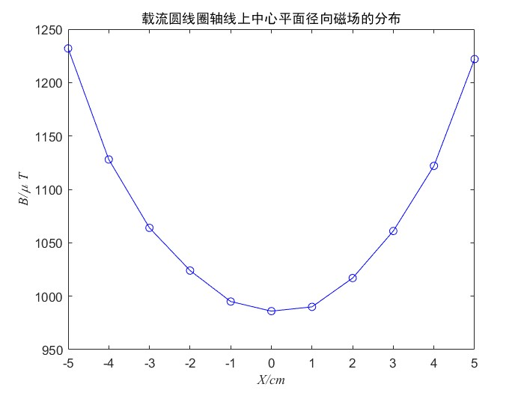

实验3 测量亥姆霍兹线圈轴线上磁场的分布

|  |  |  |  |  |  |  |  |  |  |  |  |
| --- | --- | --- | --- | --- | --- | --- | --- | --- | --- | --- | --- |
| 轴向距离 | 10.00 | 9.50 | 9.00 | 8.50 | 8.00 | 7.50 | 7.00 | 6.50 | 6.00 | 5.50 | 5.00 |
| 磁感应强度 | 871 | 922 | 980 | 1033 | 1087 | 1140 | 1186 | 1229 | 1270 | 1302 | 1330 |
| 轴向距离 | 4.50 | 4.00 | 3.50 | 3.00 | 2.50 | 2.00 | 1.00 | 0.00 | -1.00 | -2.00 | -2.50 |
| 磁感应强度 | 1353 | 1364 | 1375 | 1387 | 1390 | 1393 | 1400 | 1400 | 1404 | 1397 | 1394 |
| 轴向距离 | -3.00 | -3.50 | -4.00 | -4.50 | -5.00 | -5.50 | -6.00 | -6.50 | -7.00 | -7.50 | -8.00 |
| 磁感应强度 | 1387 | 1375 | 1362 | 1344 | 1320 | 1290 | 1257 | 1215 | 1172 | 1129 | 1082 |
| 轴向距离 | -8.50 | -9.00 | -9.50 | -10.00 |
| 磁感应强度 | 1032 | 976 | 925 | 870 |

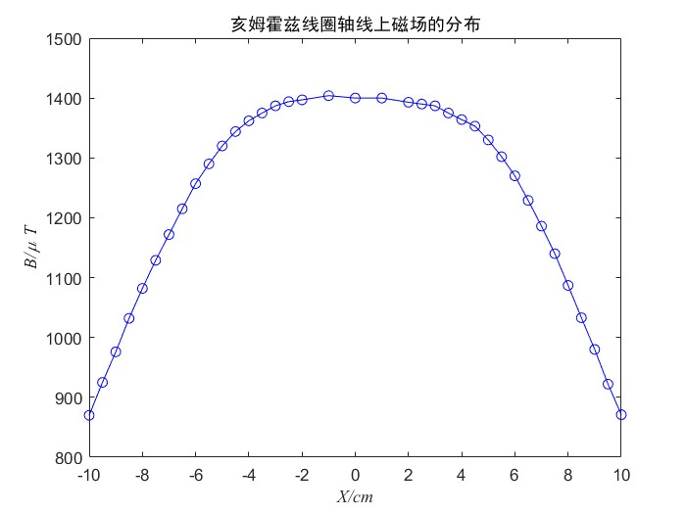

处磁感应强度理论值

相对误差